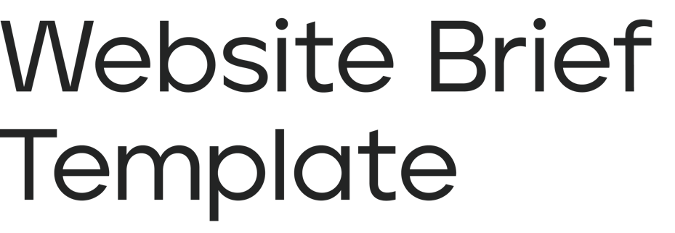

Here’s a simple template for a website brief based on the factors we’ve discussed in the How to Write a Perfect Web Brief ebook. It’s by no means the only way to write a brief, but it will put any agency in the best place to create an informed proposal for you.
If you want an accurate quote, and to be sure that your chosen agency can meet your needs, it’s helpful to provide as much information about your requirements as possible. Writing project briefs for websites that integrate with ticketing systems or external software are a bit different to writing ones for websites that don’t.
- Who we are
Tell us a bit about your organisation and its current position in your industry or market. What are your core values? How are you perceived and how would you like to be perceived?

2. What we do
Tell us about what your organisation is offering: your products and/or services. What are the unique selling points of these products and/or services? Do you want people to buy products or schedule services directly through your website?

3. Our competitors
Tell us about any competitors with a similar service offering to you, if you have any. How are they different to you? What are you doing better? What are they doing better?

4. Our audience
Tell us about the audience groups that make up your customers, clients, or service users. What are the main demographics of your audience? Are they local to you? Are they your ideal audience? Are there any new audiences that you want to begin targeting?

5. What we need
Tell us what services you want a web agency to provide – a new website and everything else. Do you need support with content creation, such as branding, copywriting, or photography? E.g. web design, web development, ecommerce, software integrations, marketing, hosting, competitor analysis, audience personas, keyword research, SEO etc.?

6. Aims and objectives
Tell us about the primary goals for the new website that will measure the project’s success e.g. more sales or bookings, increased newsletter signups, heightened brand awareness and service visibility, improved accessibility and sustainability, better mobile user experience etc.

7. Web pages
Tell us about any key pages on your current site and any you’d like on your new site. How many webpages does your current site have? Do you have a website structure in mind? E.g. products, services, resources, about us, our team, contact, testimonials etc.

8. Web content
Tell us about any content found on your current website and any you want on your new site? How much content will need migrating from your existing site and how much will be new? E.g. product listing, case studies, videos, images, news articles, blog posts, documents etc.

9. Web features
Tell us about any unique features on your current site or any you want to see on your new site. Are there any notable features you have on your current site or ones you’d like us to build? E.g. resources library, interactive maps, forms, databases, quote tools, live chat support etc.

10. Web platform
Tell us about the platform or CMS (content management system) your current site is built on. E.g. WordPress, Drupal, Umbraco, Joomla, Craft, Concrete5, Ruby on Rails, etc. Are you looking to use the same CMS, or switch to a different one?

11. Any external software integrations
Tell us about any additional external software your new site needs to work in conjunction with. If you use any digital tools or platforms to run your business, do these need to be integrated? E.g. external sales platforms, mailing list tools, learning management systems, content libraries, secure login areas, CRM tools, room hire/appointment booking software etc.

12. Current site weaknesses
Tell us about the issues you experience with your current website. What issues do your users face? What issues do your web management team face?

13. Current site strengths
Tell us about the strengths of your current website. What do you like about it and are there any features you would like to retain?

14. Website inspiration
Tell us about any websites that you like and how you’d like your new site to emulate them. Are there any websites you enjoy (or don’t enjoy) in your sector and beyond? What about their aesthetics or functionality inspires you?

15. Deadlines
Tell us your deadlines for receiving a quote, starting the project, and launching the website.
Are there any specific reasons for these deadlines? Are they fixed or flexible?

16. Budget
Tell us about your budget for the project, if possible, either fixed or approximate.
If you do have a specific figure in mind, does that figure include or exclude VAT? Does that figure need to include any initial hosting costs, or are these separate?

